**Launch Linux EC2 instances in two regions using a single Terraform file.**

1. Created a directory **terraform**

2. Created a file **provider.tf** with below code,

2a. Creating instance in 2 different regions – **ap-southeast-1 & ap-southeast-2.**

Note: Hiding my **access key and secret key**

provider "aws" {

alias = "se1"

region = "ap-southeast-1"

access_key = "XXXXXX"

secret_key = "XXXXXX"

}

provider "aws" {

alias = "se2"

region = "ap-southeast-2"

access_key = "XXXXX"

secret_key = "XXXXX"

}

2b. Terminal screenshot,

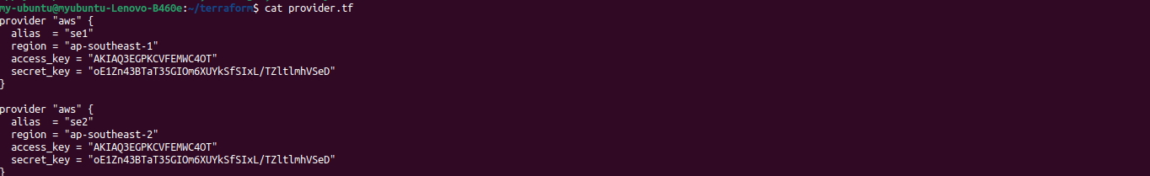

3. Created a main terraform file **main.tf** with below code,

3a. Assigning resource as **Linux1 & Linux2** mentioning the corresponding ami ids

terraform {

required_providers {

aws = {

source = "hashicorp/aws"

version = "5.54.1"

}

}

}

resource "aws_instance" "Linux1" {

provider = aws.se1

ami = "ami-04c913012f8977029"

instance_type = "t2.micro"

tags = {

Name = "account-se1",

Region = "ap-southeast-1"

}

}

resource "aws_instance" "Linux2" {

provider = aws.se2

ami = "ami-0e326862c8e74c0fe"

instance_type = "t2.micro"

tags = {

Name = "account-se2",

Region = "ap-southeast-2"

}

}

3b. Termial screenshot,

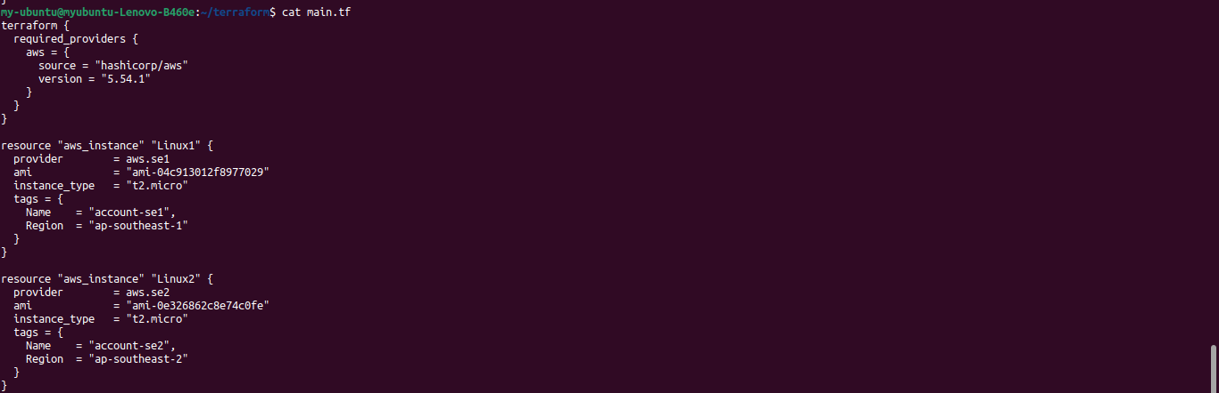

4. Initialising Terraform using **terraform init** command,

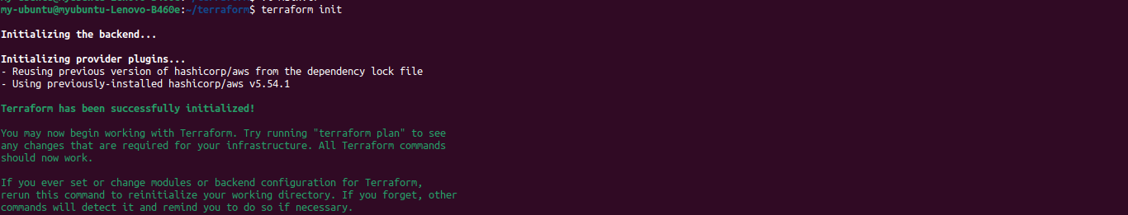

5. Planning Terraform using **terraform plan** command,

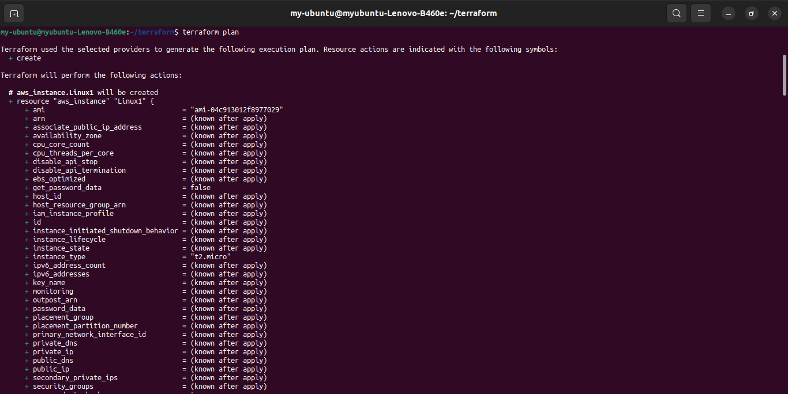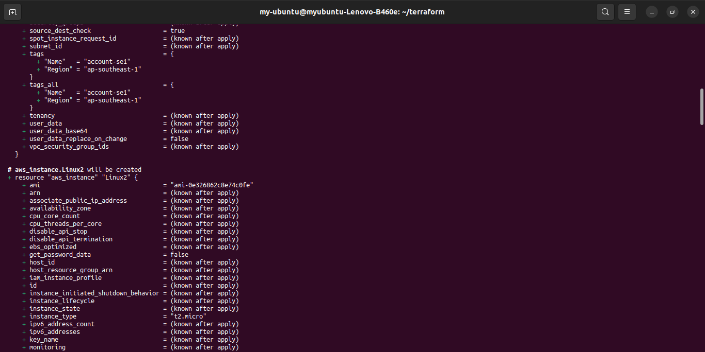

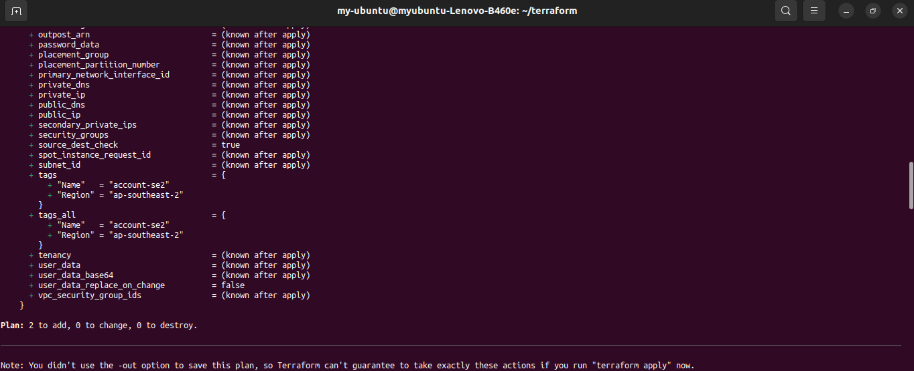

6. Applying terraform using **terraform apply** command,

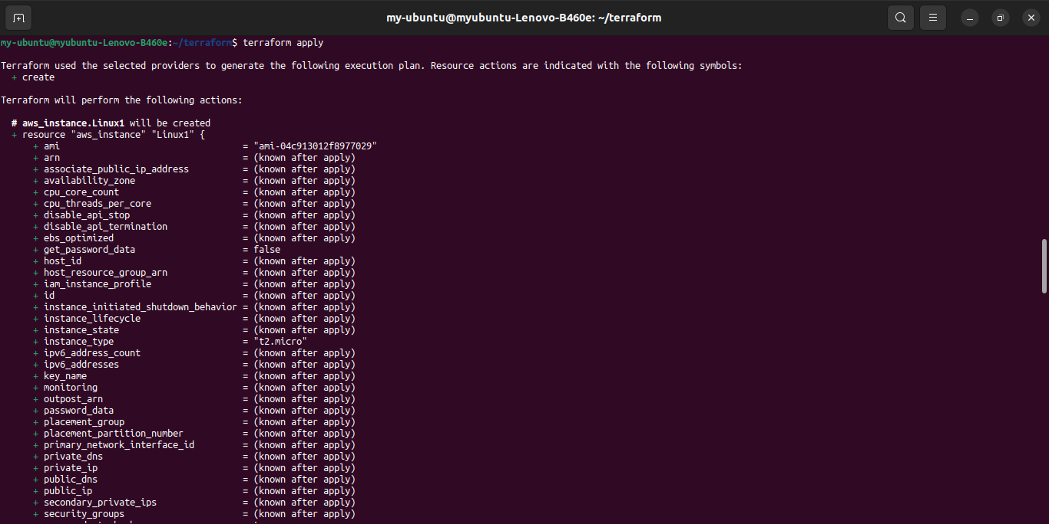

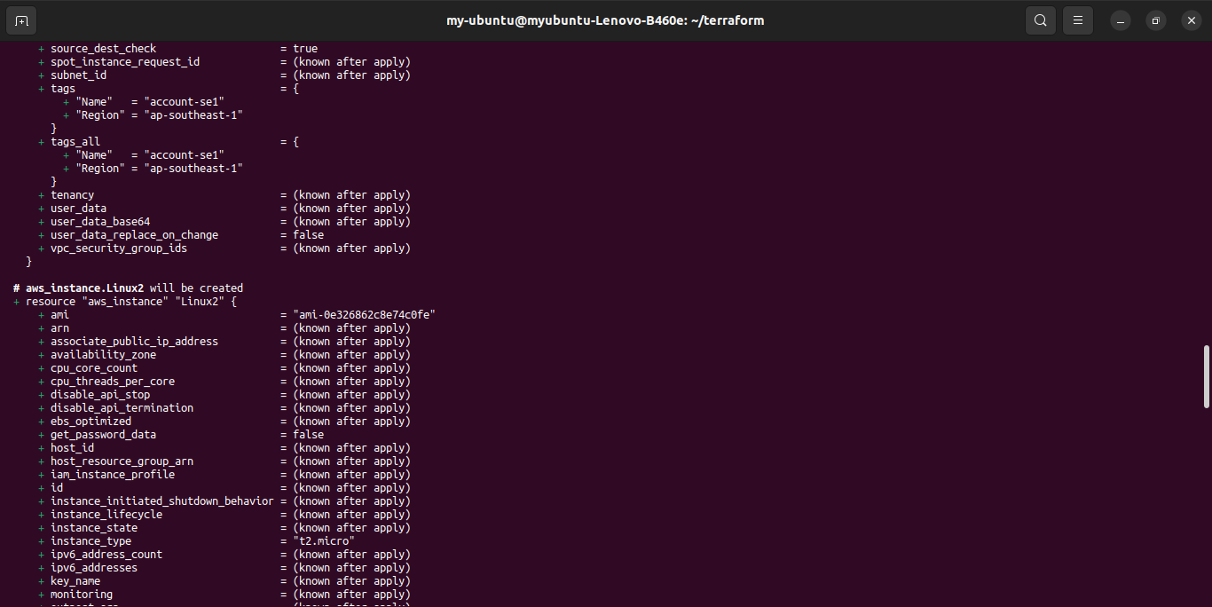

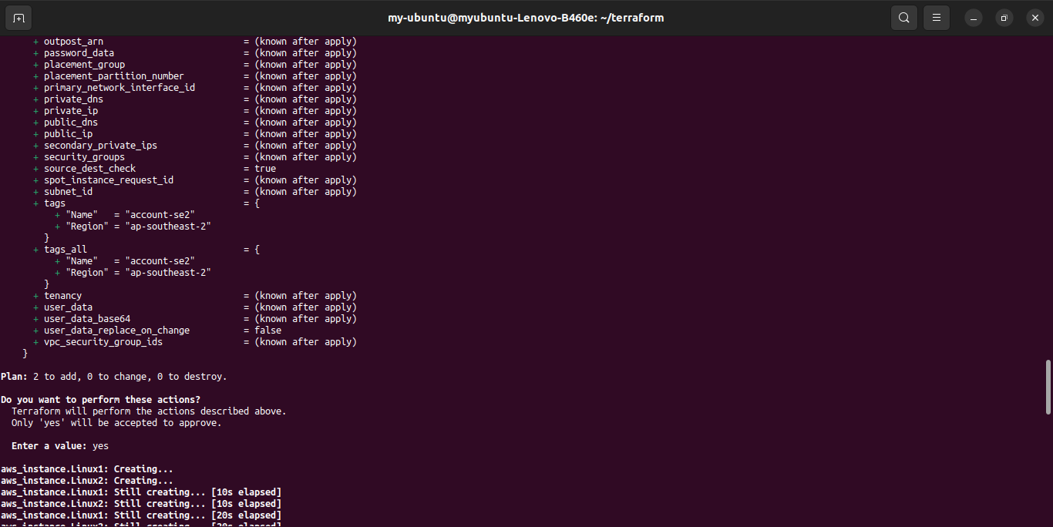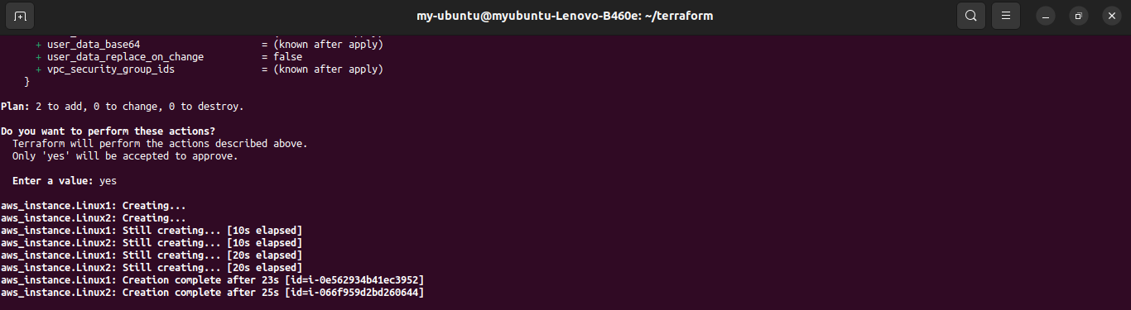

7. AWS console screenshot showing **2 instance** created in **2** different regions **Singapore and sydney**

